**Name: G. Bhuvana Chandrika**

**Trainer Name: Harshee Pitroda**

**Course Name: Python & machine Learning Basics**

**Date:06/06/2022**

**1)**



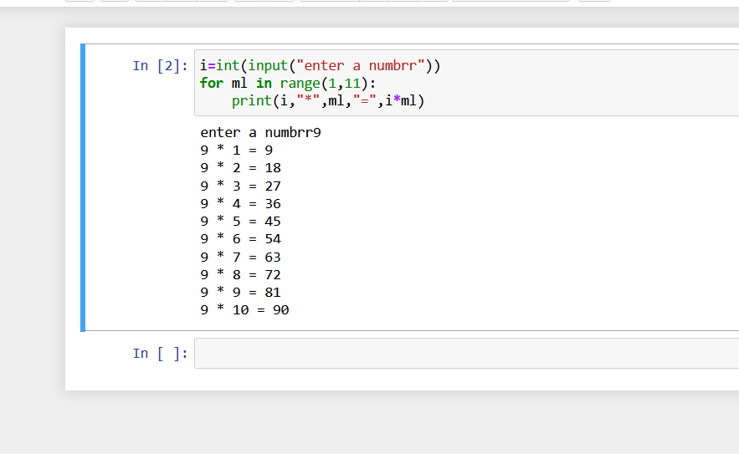

2) <https://www.hackerrank.com/challenges/python-loops/problem>

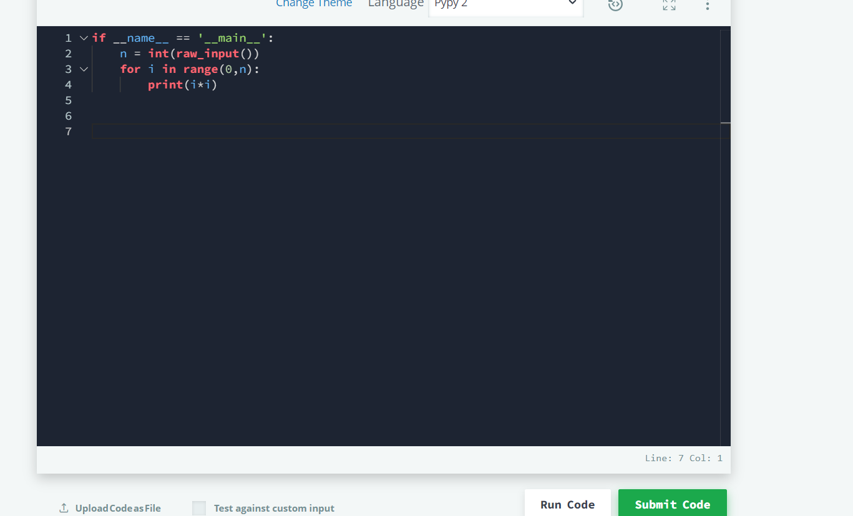

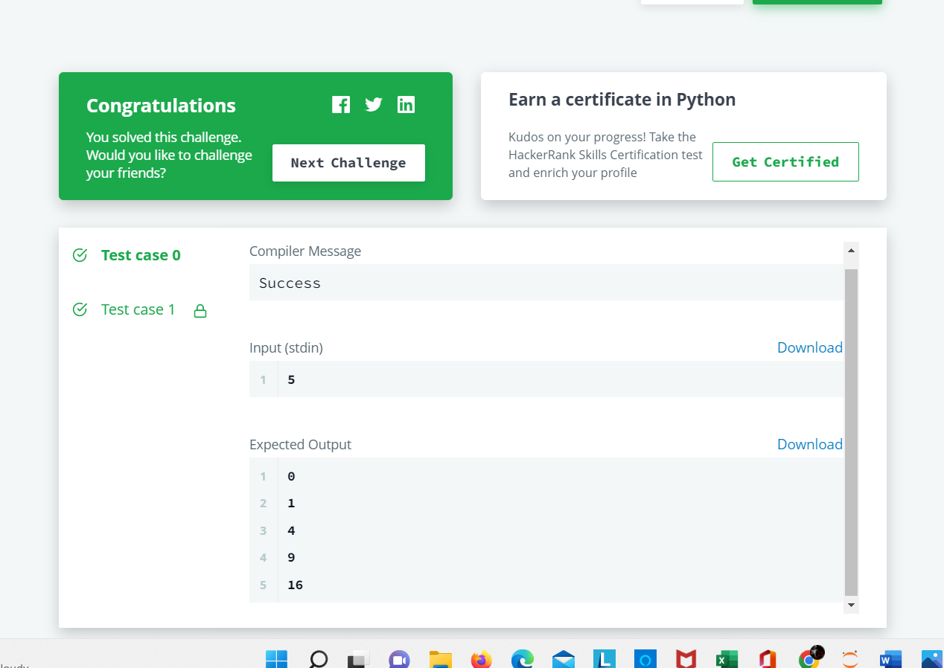

3)

<https://www.hackerrank.com/challenges/py-if-else/problem?isFullScreen=true>

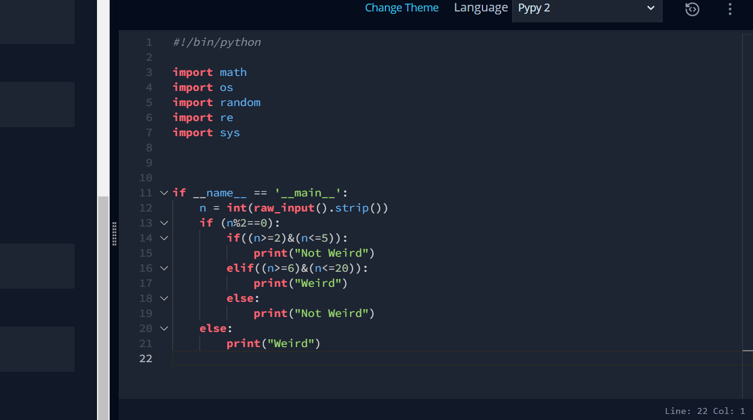

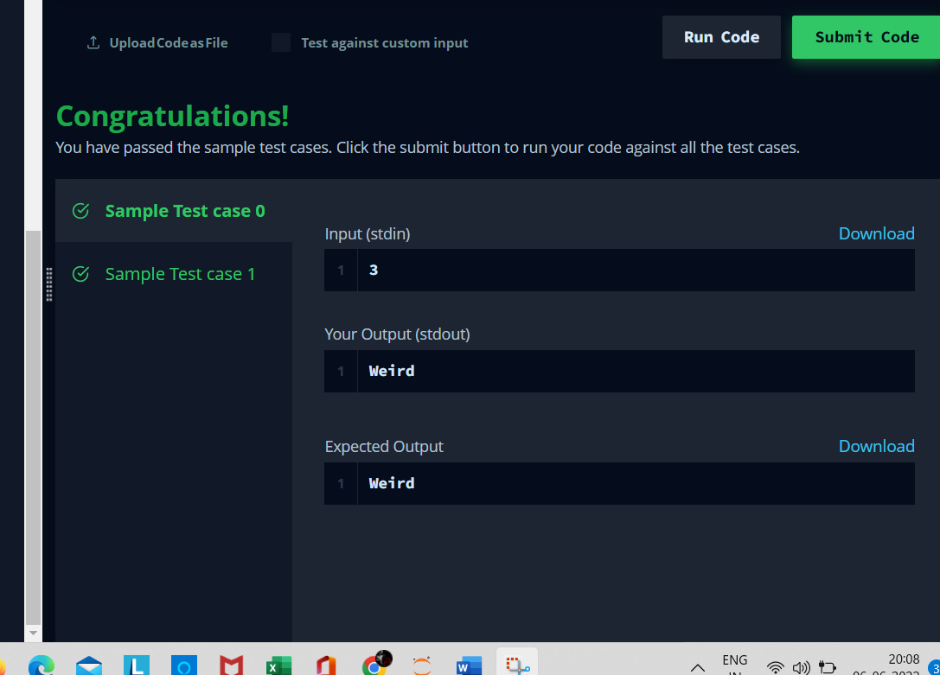

4)

<https://www.hackerrank.com/challenges/whats-your-name/problem?isFullScreen=true>

